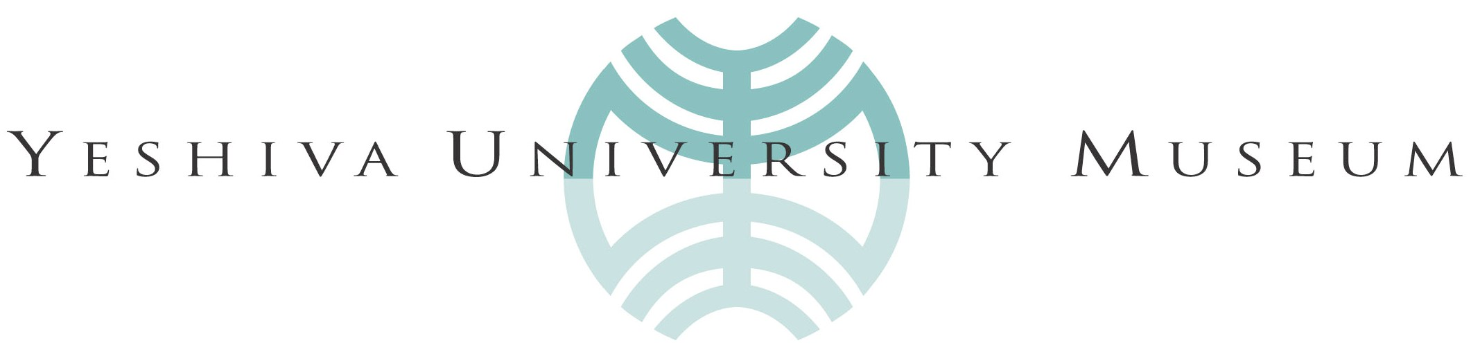

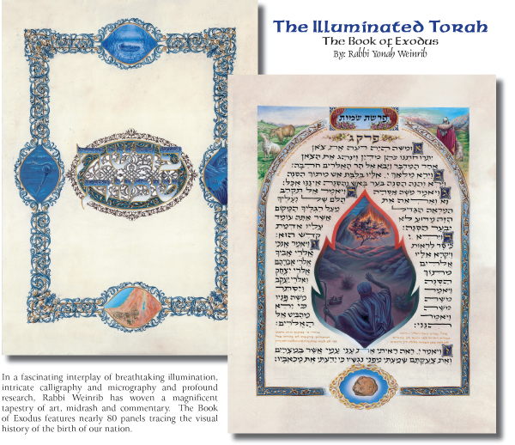
The Illuminated Torah: Yonah Weinrib
The Book of Exodus: Illumination, Calligraphy and Commentary
February 4 – May 20, 2007

Yeshiva University Museum announces an exhibition of works by Rabbi Yonah Weinrib, on view in the Popper Gallery from February 4 – May 20, 2007. The exhibition of all new work will include 55 illuminations of the Biblical Book of Exodus on parchment.

Weinrib is a master of calligraphy, micrography, and papercut, and his mediums include gouache, acrylic, pen and ink, and watercolor. Every aspect of his art, from the ornamentation and illumination to the illustrations themselves, is informed by his own profound Biblical scholarship, with written commentary accompanying each piece. A limited edition facsimile with a full English translation and commentary, is being created specifically for the project.

A Torah scholar and Judaica artist for many years, Rabbi Weinrib has published art volumes on Pirkei Avot/Ethics of the Fathers, Hallel, Bar and Bat Mitzvah, Megillat Esther, the Manuscript Shiron, a series on Birkat Hamazon, and numerous individual commissions. He has lectured and exhibited internationally, and his works are featured in private collections, museums, and galleries worldwide. This is the third exhibition of his work at Yeshiva University Museum.

Artist’s Talk and Reception: Tuesday, February 13, 6 – 8pm

Caption: Yonah Weinrib, Exodus.

ALSO ON VIEW IN FEBRUARY:

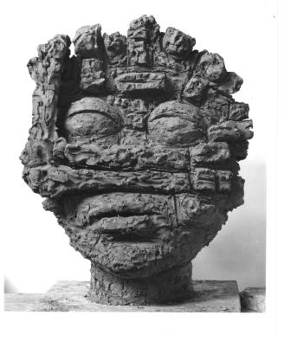  Reuben Kadish, Holocaust Head, 1985, 25 x 18 x 16 in. | Reuben Kadish’s Holocaust Sculpture  Sculpture Garden  February 4 – April 22, 2007  An exhibition of three bronze sculptures inspired in part by the artist’s experiences in Burma and India during World War II. These deeply scored bronze works reflect Kadish’s Abstract Expressionist roots and reveal his reaction to the horrific events and crimes against humanity that he personally witnessed during the war. Specific references include the Holocaust and Hiroshima.
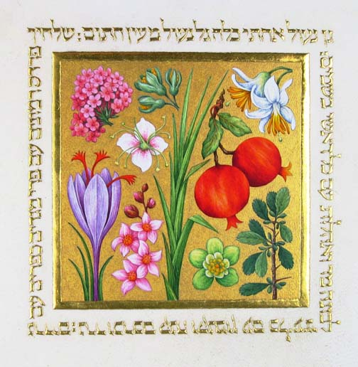  Barbara Wolff, An Enclosed Garden. | A Talent of Pure Gold: Illuminated Miniatures by Barbara Wolff  Exhibition Arcade  February 15 – May 31, 2007  Artist’s Talk and Reception: Thursday, February 15, 6 – 8pm  New York artist Barbara Wolff will exhibit a series of illuminated miniatures. Works incorporate images of fruit, flowers, and landscapes, referencing the use of the natural world as metaphor in Biblical literature. In her work, Wolff uses Medieval and Renaissance techniques and materials such as burnished gold, lapis lazuli, and malachite on velum.

LISTING INFORMATION:
What: Yeshiva University Museum
Where: Center for Jewish History: 15 West 16th Street (between 5th & 6th Aves), NYC
Access: Union Sq: Q, W, N, R, 4, 5, 6; 14th St at 7th Ave: 1, 2, 3, 9; 14th St at 8th Ave A, C, E
Admission: $8 for Adults; $6 for seniors and kids
Public Info: (212) 294-8330 www.yumuseum.org

Media Inquiries: Stacy Bolton Communications T. 212.721.5350 E. emily@stacybolton.com

